**Highways Construction**

Jian Yang is now the mayor of Silicon Valley. He wants to improve the traffic situation of the valley and has decided to upgrade certain roads to a national highway. There are N cities and M roads in the valley. Roads are bi-directional and there is exactly one path from one city to another city.

A highway is a path from one city to another city through one or more cities via connecting roads. He wants the highway to be as long as possible. Keep in mind that no new road should be constructed, only the existing roads needs to be upgraded.

You need to find the length of the longest highway that can be constructed in the valley.

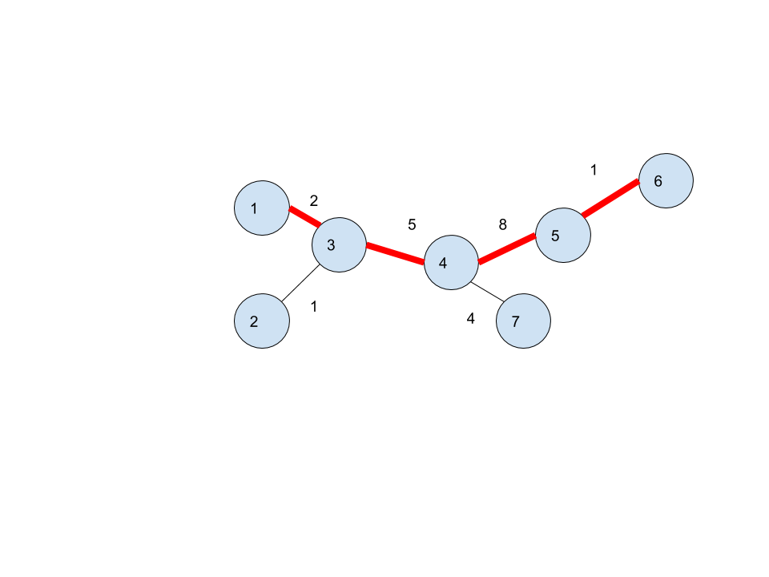

Input:

First line contains N and M, the number of cities and the number of roads respectively.

Next M line contain three integer each x y z, the x and y are the cities between which road exist and z is the length of the road.

Output:

Print one integer, the length of largest possible highway.

Constraints:

1<=N, M<=100000

1<=x,y<=N

1<=z<=1000000

Sample input 1:

7 6

1 3 2

2 3 1

4 3 5

4 7 4

4 5 8

5 6 1

Sample output 1:

16